Name Shayan fatima

Roll num : 25k-0014

Link : [k250014Shayanfatima/lab3homework](https://github.com/k250014Shayanfatima/lab3homework)

TASK 1:

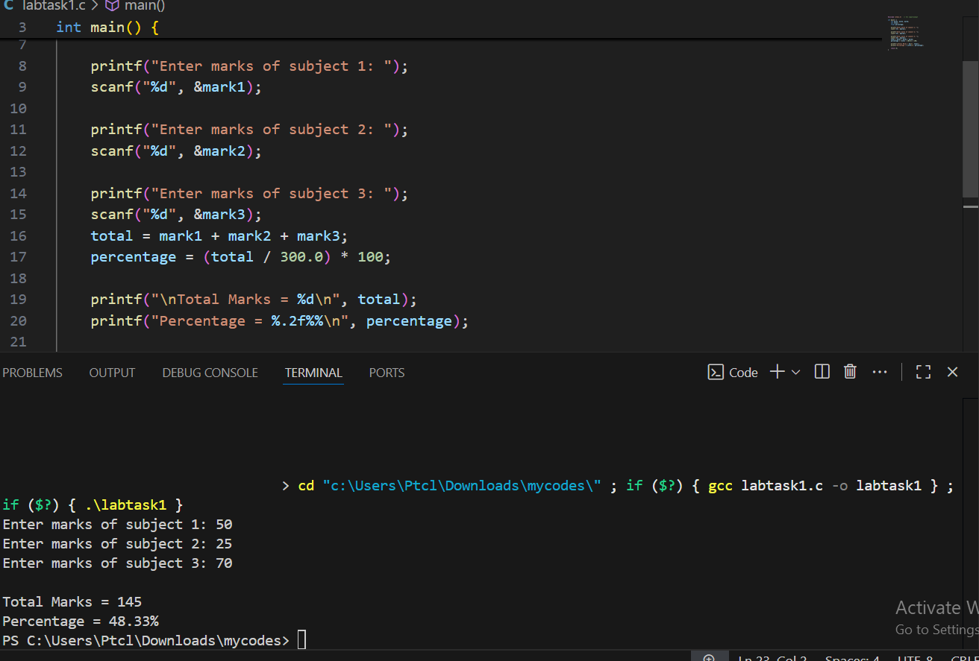

TASK 2:

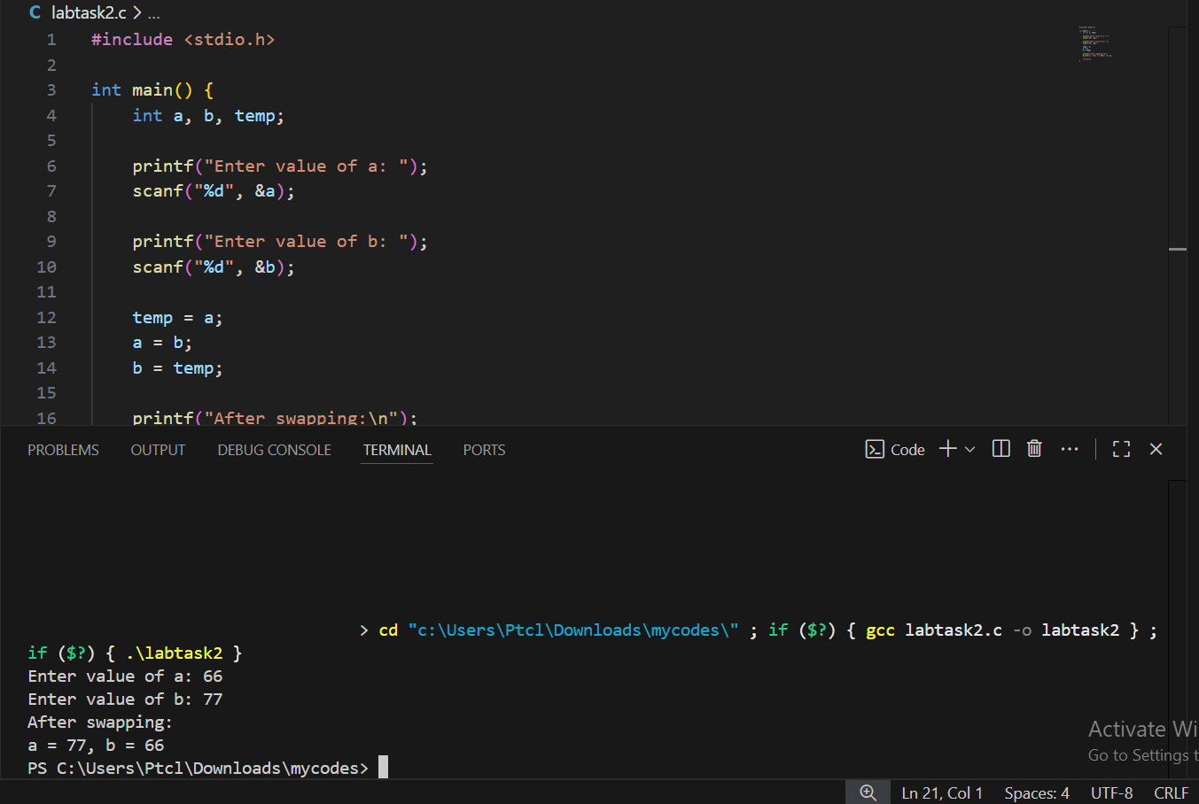

TASK 3:

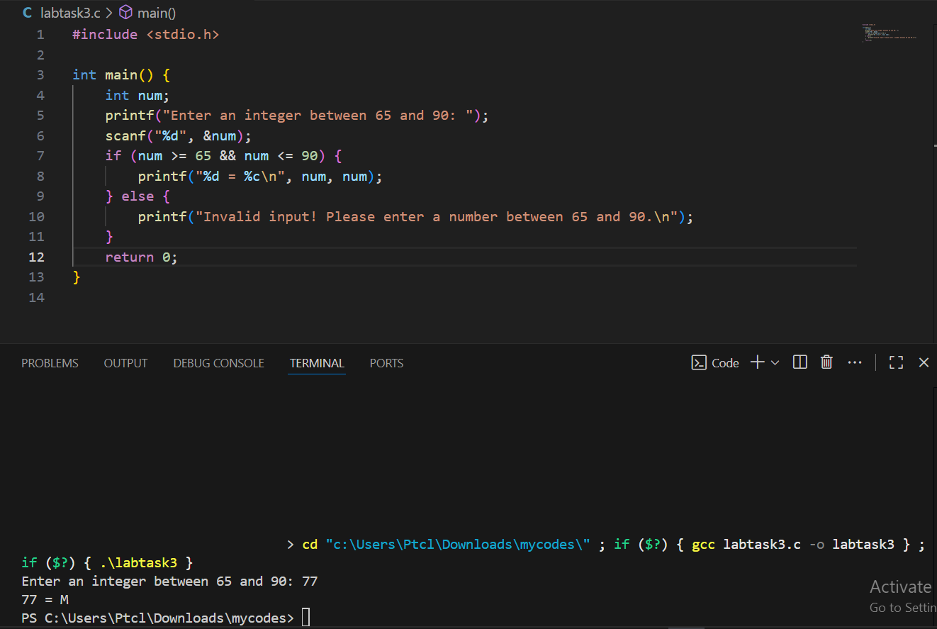

TASK 4:

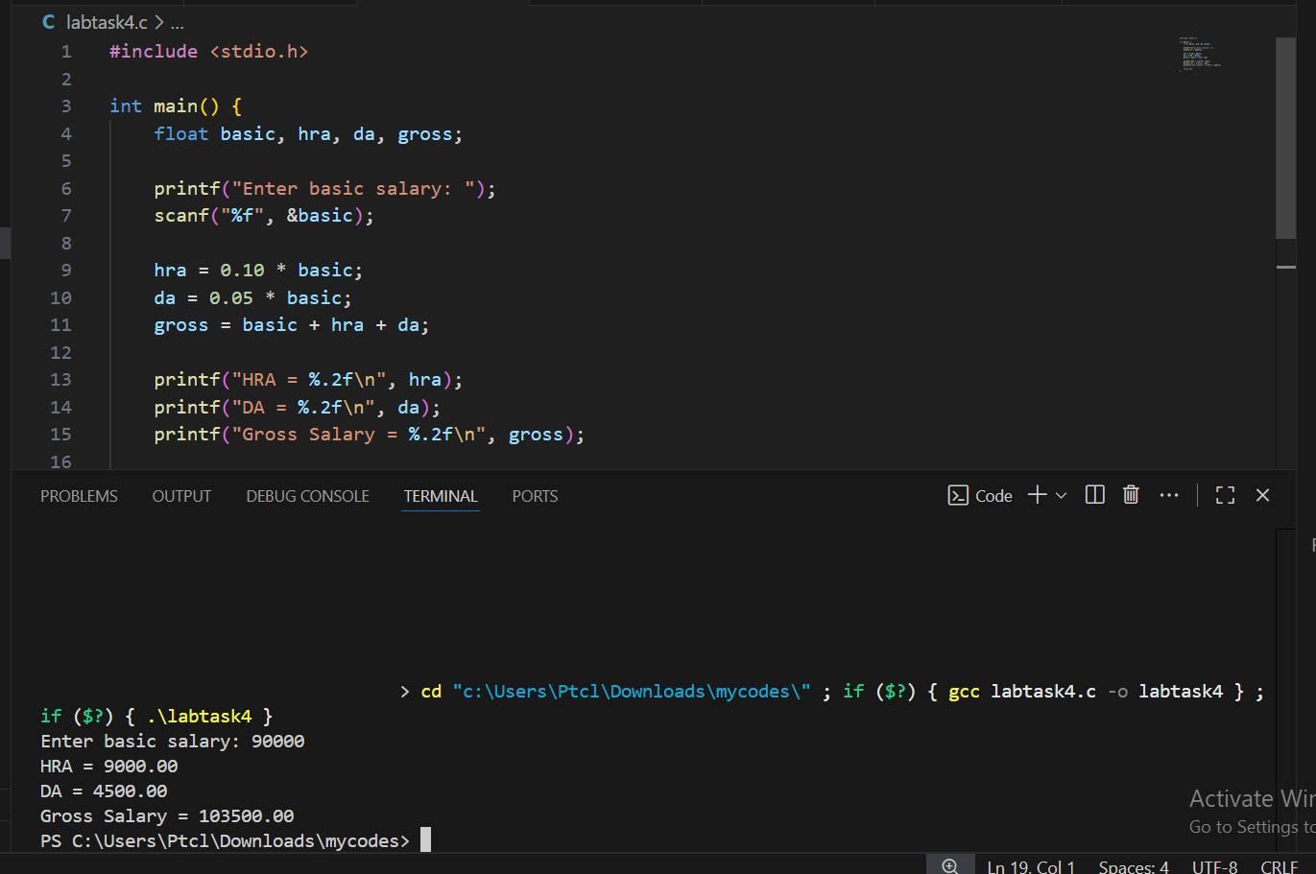

TASK 5